Welcome to Studio B Dance Company!

We are so glad to have you and your dancer to express interest in our Studio B dance program. Enclosed in this welcome packet you will find important information including:

- How to Register and Pay for classes
- Studio B class schedule for Summer (August)
- Studio B class schedule for the 2018-2019 School Year (September-May)
- Information on class dresscode and where to purchase the items for the dresscode
- Calendar that includes dates classes will not meet due to Holidays, special events, etc

- Documents that must be signed and returned
  - Parent Ackowledgment of Policies and Procedure
    - Please visit our website www.tallyarts.com to view our policies and procedures
  - Autodraft Form (optional)
  - Class Registration, Tuition and Fee Worksheet

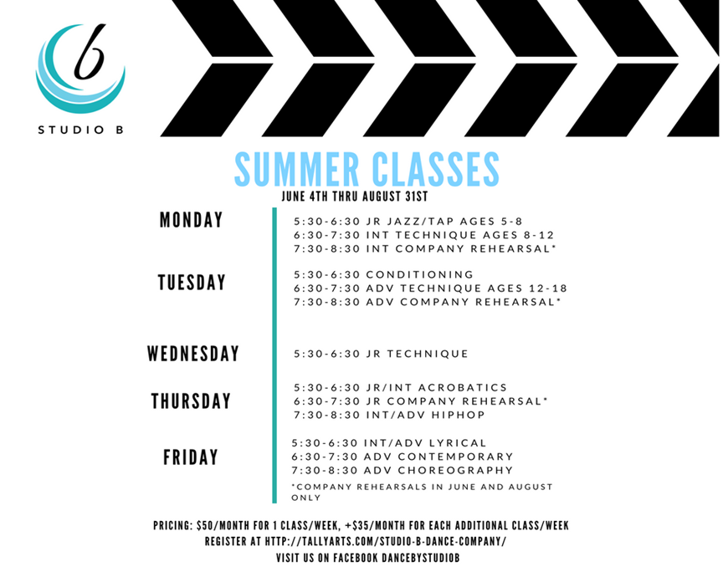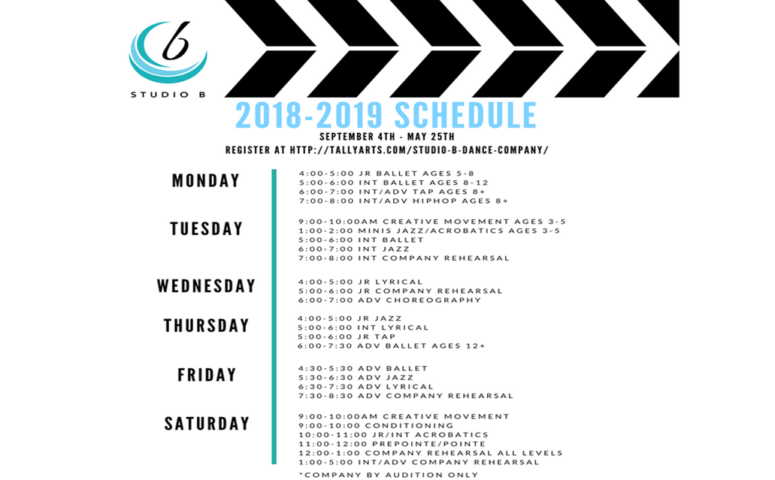
Registration
To register for classes, you must complete the online registration and create a Procare account on our website: www.tallyarts.com. Please print the registration from the website and submit it with the class registration, tuition and fee worksheet, as well as the Parent Acknowledgment of Policies and Procedures page enclosed in this packet. The Procare account is a necessary step in the registration procedure, as it allows us to link the parent to the student and process payments. We do accept a variety of payment methods, including cash, check, autodraft or credit card. In order to pay by credit card, you must come to our facility and our office staff will set up a finger scan for you on our kiosk. Once this is complete, you can pay at the kiosk by card.
Pricing: Tuition and Additional Fees
Monthly tuition is calculated by the number of classes a student takes each week. 1 class/week is $50/month. Each additional class/week is +$35/month. For example, if your student will be taking 3 classes/week, the tuition will be calculated as $50 + $35 + $35 = $120/month. Please note, tuition is due by the 5th of each month. Autodraft payments will be ran between the 1st and 5th of the month. Failure to pay tuition by the 5th of the month will result in a late payment fee of $10/day late. Returned payments (check or declined autodraft) will result in a returned payment fee of $25.
If your child misses class for whatever reason, they are invited to make up that class by attending one of the other classes offered for their level within a week of their absence. Due to the large number of classes we offer in our program, we will not schedule a private make-up class for absences nor will we pro-rate tuition. In the event a class is canceled by Miss Brittany, an alternative class from our program will be offered as a make-up class or under very extreme circumstances, a separate make-up class day will be scheduled. In addition, prorated tuition will not be offered during months with extended holidays.
School year registration is intended for a 10-month commitment (beginning September 4th and concluding May 31st). If at any time during this 10-month period, you elect to terminate services, we require a 30-day written notice. You will be accountable for any outstanding balance, as well as any tuition that accrues during the 30-day notice. Tuition, registration, recital, and costume fees are nonrefundable.
Private lessons are $30/hour and do not require a 10-month commitment, however private lesson tuition will be calculated for the entire month that your student is receiving private lessons. Private lesson students are invited, though not required to participate in our recital.
Annual Registration Fee is $55/student with a $75/family cap. This fee applies to every student participating in the Studio B dance program (including company members and private lessons). The Annual Registration fee is due with September tuition or upon initial enrollment (if registering late).
Recital Fee is $50/student. With this fee, you will receive 2 tickets to the recital. The Recital Fee is due with the Recital Costume Fee(s) on November 1st.
Recital Costume Fee(s) are $50 per class, using the guidelines below:
- Jr/intermediate/adv ballet (only 1 costume fee for students taking both intermediate or advanced ballet classes or pointe/prepointe)
- jr jazz and jr tap (will use same costume – only 1 costume fee)
- intermediate jazz and int/adv tap (will use same costume- only 1 costume fee)
- adv jazz and int/adv tap (will use same costume – only 1 costume fee)
- jr lyrical
- int lyrical
- adv lyrical
- creative movement
- mini’s jazz/acro
*HipHop and jr/int acrobatics will use dancewear from our class dresscode for their recital performances.

Dresscode
All students must comply with the Studio B dresscode. The dresscode items are to be purchased directly by the parent on the discount dance website (www.discountdance.com) where I have set up a dresscode list under Studio B Dance Company Arts Afterschool. Please use my teacher code (TP104454) to receive a discount. There are a few cheaper optional class leotards to choose from, however please make note of the required performance leotard, tights and shoes. The specific shoe and shoe color is less important in class, but will be required for all performances including semester demonstrations, Celebration of Lights, Springtime Tallahassee and our recital. All leotards to be worn in class must be selected from one of the approved (required or optional) leotards from the discount dance dresscode.
In addition, all classes (except ballet) must purchase jazz shorts with the studio b logo from our teamstore. Our teamstore link is https://teamstore.gtmsportswear.com/StudioBDance. The required item is the Groove short (~$30).
Summary of Dresscode by Class
All classes leotards
- optional: N5500 Adult Camisole Cotton Dance Leotard (turquoise - $12.95), N5500C Kids Camisole Cotton Dance Leotard (turquoise - $9.98), TH5527 Adult Triple Strap Tank Dance Leotard (turquoise - $19.95), TH5527C Child Triple Strap Tank Dance Leotard (turquoise - $18.95)
- required: N7264 Adult Emballe Lace Boatneck Tank Leotard (royal - $29.15), N7264C Child Emballe Lace Boatneck Tank Leotard (royal $27.32)

Creative Movement/Jr Ballet/Int Ballet/Adv Ballet/Pre-pointe/Pointe:
-Leotard (above)
-pink tights for in class (T5515 Adult Convertible Tights with Smooth Self-Knit Waistband $5.50 or T5515C Girls Convertible Tights with Smooth Self-Knit Waistband $4.50)
-theatrical pink tights for performances (A81 Adult totalSTRETCH Convertible Tights $11.17 or C81 Girls totalSTRETCH Convertible Tights $9.12)
-pink ballet shoes (T2915 Adult "SofTouch" Canvas Stretch Split-Sole Ballet Shoes $12.56 or T2915C Girls "SofTouch" Canvas Stretch Split-Sole Ballet Shoes $11.96)
-TH5109 Adult Sheer Wrap Skirt $12.95

Mini’s Jazz/Acro/ Jr Jazz/ Int Jazz/ Adv Jazz:
-Leotard (above), tan tights are optional for in class
-Groove short from our Teamstore (https://teamstore.gtmsportswear.com/StudioBDance)
jazzy tan tights for performances (A81 Adult totalSTRETCH Convertible Tights $11.17 or C81 Girls totalSTRETCH Convertible Tights $9.12)
-tan no-lace jazz shoes (T7602 Adult Gore Insert Jazz Boot $21.56 or T7602C Girls Gore Insert Jazz Boot $20.25)

Jr Tap/ Int/ Adv Tap: same as above, black tap shoes (T9555 Adult Split Sole Tap Shoes $32.36 or T9555C Child Split Sole Tap Shoes $26.66)
Jr/Int Acro: same as above (jazz), no shoes required
Int/Adv HipHop: same as above (jazz), T8000 Adult Split-Sole Sneaker $31.46 or T8000C Girls Split-Sole Sneaker $31.46
Jr lyrical/ Int Lyrical/ Adv Lyrical/ Adv Choreography: same as above (jazz), T8975 "Lyrical Flow" Canvas Closed-Toe Lyrical Shoes (tan)

Calendar: Dates classes will not meet and Special Events
-Friday July 27th 6p- Saturday July 28th 9am
- Party All-Night Lock-In $30/child and $10 off siblings
- Monday July 30th – Friday August 10th 8am-6:30pm (M-F only) FALL REGISTRATION
-Monday August 13th – Friday August 24th 4pm-6:30pm (M-F only) Fall Registration
-Saturday September 1st – Monday September 3rd NO CLASS Labor Day Weekend
-Tuesday September 4th 2018-2019 School Year Schedule begins!
-Saturday September 8th Chipotle Share Night 3425 Thomasville Rd 4p-8p
- Come out to support our program and tell your friends!
-Saturday September 15th CarWash Fundraiser HealthSource of Tallahassee on Mahan 9am-2pm
- $20 buys you a CarWash, a backmassage by HealthSource staff and a $5 SweetFrog giftcard
-Wednesday September 19th Fall Holiday (no school or regular class)
-September 27th-September 30th BurgerFi Sharenights (bring your coupon!) 1817 Thomasville Rd. All day
- Come out to support our program and tell your friends
-Friday October 12th Teacher Planning Day (no school or regular class)
- Workshop 9am-12p $25 open to Jr, Int, and Adv level students
-Monday October 15th thru November 3rd Johnston Meat Fundraiser
- Purchase delicious Johnston smoked meat packages from Studio B to prepare for your Thanksgiving family gatherings. Orders will be collected during the dates above and will be delivered to Arts on Friday November 16th. Prices are $30 per 3lb-5lb package and include choices such as Ham, Sausage, and Boston Butt.
-Saturday October 27th Foundation4ARTS Fall Festival Fundraiser 4p-8p
- Enjoy some family fun for kids of all ages! Games, prizes, trunk-or-treat, haunted house, costume contest, food, and entertainment!
-Thursday November 1 Skate World Share Night 4p-8p
- Come out to support our program and skate the night away. Don’t forget to tell your friends!
-Monday November 12th No School or Classes
-Friday November 16th Johnston Meat Pickup 4p-6:30p at ARTS
-Monday November 19th-Sunday November 25th NO CLASSES (Thanksgiving Break)
-Friday November 30th Celebration of Lights Rehearsal 6p-8p (by special invitation only)
-Saturday December 1st Celebration of Lights Performance Time TBA
-Tuesday December 4th Sonny’s BBQ Share Night Dick Wilson Blvd 4p-9p
- Make dinner an easy choice and eat out at Sonny’s! Don’t forget to show your Studio B flyer and tell your friends!
-Friday December 14th Winter Demonstration at Arts (TBA) All classes
-Saturday December 15th Zaxby’s Share Night on Mahan
-Wednesday December 19-Friday December 21st Early Release Days and Saturday December 22nd *Classes will meet!
-Monday December 24th-Monday January 7th No Classes *Winter Break
-Saturday January 5th and Sunday January 6th Weekend Workshop TBA
- Grab a Krispy Kreme donut or a dozen when you drop off your dancer!
-Tuesday January 8th Classes Resume
-Monday January 21st MLK School Day Off No regular classes
- Workshop 9am-12p $25 open to Jr, Int, and Adv level students
-Saturday February 16th Daddy/Daughter Ball Fundraiser
- Join us for a 50’s style sock-hop celebrating dads and daughters! We will have food, games, dancing and daddy/daughter bonding! Order your tickets in advance for a discount!
-Monday March 18th-Monday March 25th NO CLASS SPRING BREAK and Johnston Meat Fundraiser
- Purchase delicious Johnston smoked meat packages from Studio B to prepare for your Easter holiday family gatherings. Orders will be collected from March 18th- April 6th and will be delivered to Arts on Thursday April 18th. Prices are $30 per 3lb-5lb package and include choices such as Ham, Sausage, and Boston Butt.
-Friday April 5th Springtime Tallahassee Rehearsal 6p-8p (by special invitation only)
-Saturday April 6th Springtime Tallahassee Performance time TBA
-Saturday April 13th Jr Chef Competition Fundraiser
- Know a child with a keen interest in cooking? Allow your child (ages 5+) to join one of three Chef teams for a friendly cooking competition. Chefs will mentor their teams and a panel of judges will decide the winning team! Purchase an entry ticket to participate on a team and/or watch the excitement as an observer!
-Thursday April 18th Johnston Meat Pickup
-Friday April 19th Spring Holiday – School Day Off – No regular classes
- Workshop 9am-12p $25 open to Jr, Int, and Adv level students
- Saturday May 11th Mother’s Day Craft Morning/ Parents Morning Out Fundraiser 9am-12pm
- Your child will enjoy preparing a special mother’s day craft, games, and snack while parent’s can enjoy a morning out. $25/ child and $5 off siblings
-Saturday May 18th Recital Picture Day –TBA
-Saturday May 25th Recital finale rehearsal 2p-4p
-Friday May 31st Recital Dress Rehearsal Lee Hall Auditorium TBA
- We will be selling pizza at the rehearsal
-Saturday June 1st Recital at Lee Hall Auditorium 10:30am
- Order some flowers for your dancer’s special recital performance! Pre-order or purchase at the recital.
-Monday June 3rd Summer Schedule begins

Class Registration

Student’s Name: _______________________________ Date of Birth (MM/DD/YYYY): ______________
Mailing Address: ______________________________________________________________________
Primary Phone: ________________________________ Phone (2): _____________________________
Parent(s) Name: ________________________________________________
Anticipated Method of Payment: ACH Autodraft____ Credit Card____ Cash/Check____ Credit Card____
Credit card Information if applicable:
Name on Card ______________________________
Billing address ______________________________
Card Number _______________________________ Card expiration _____ CVV/Security code _____
Parent Contact Information
Primary Email Address: _________________________________________________________________
Primary Phone # ______________________________
Emergency Contact Information
Name ___________________________________________ Relationship to dancer _______________________
Phone Number ____________________________________
Legal Release and Policy Acceptance (please initial)
___ I/we understand the Studio Policies outlined in the Handbook including billing obligations, risks related to dance, class dress code, class schedule, attendance policy, responsibilities for my property, company requirements and code of conduct (if applicable). I/we have completed the required ProCare registration online.
___________________________________ ______________________________
Signature / Responsible Party Date
Measurements
____ Height ___ Girth ___ Bust ___ Clothing size
____ Shoe Size ___ Inseam ___ Waist ___ Hips
Medical
Allergies: ____________________________________________________________________________
Will your child require any special medical attention during a normal class: (yes/no) __________________
If yes – Explain: _______________________________________________________________________

Classes: Please place a check next to the classes for which you are registering for August.
Class Name | Meeting Day/ Time | August
Junior Jazz/Tap ages 5-8 | Monday 5:30-6:30
Intermediate Technique ages 8-12 | Monday 6:30-7:30
Intermediate Company Rehearsal | Monday 7:30-8:30
Conditioning ages 5+ (company); ages 8+ if general | Tuesday 5:30-6:30
Advanced Technique ages 12+ | Tuesday 6:30-7:30
Advanced Company Rehearsal | Tuesday 7:30-8:30
Jr Ballet | Wednesday 5:30-6:30
Junior/Intermediate Acrobatics ages 5-12 | Thursday 5:30-6:30
Junior Company Rehearsal | Thursday 6:30-7:30
Intermediate/Advanced HipHop ages 8+ | Thursday 7:30-8:30
Intermediate/Advanced Lyrical ages 8+ | Friday 5:30-6:30
Advanced Contemporary ages 12+ | Friday 6:30-7:30
Advanced Choreography ages 12+ | Friday 7:30-8:30
Saturday Production Rehearsal (All) | Saturdays per Calendar
Saturday Solo/Duet/Trio Rehearsal (Int and Adv) | Saturdays per Calendar
Private Lessons

1st class is $50/month Number of additional classes at +$35/month ________
Number of private lessons/month ________
Total tuition for August ____________

Classes: Please place a check next to the classes for which you are registering. *September-May
Student Name________________________________________________________
Class Name | Meeting Day/ Time | Check
Junior Ballet ages 5-8 | Monday 4-5
Intermediate Ballet ages 8-12 | Monday 5-6
Intermediate/Advanced Tap ages 8+ | Monday 6-7
Intermediate/Advanced HipHop ages 8+ | Monday 7-8
Creative Movement ages 3-5 | Tuesday 9a-10a
Mini’s Jazz/Acrobatics ages 3-5 | Tuesday 1-2
Intermediate Ballet ages 8-12 | Tuesday 5-6
Intermediate Jazz ages 8-12 | Tuesday 6-7
Intermediate Company Rehearsal | Tuesday 7-8
Junior Lyrical ages 5-8 | Wednesday 4-5
Junior Company Rehearsal | Wednesday 5-6
Advanced Choreography | Wednesday 6-7
Junior Jazz ages 5-8 | Thursday 4-5
Intermediate Lyrical ages 8-12 | Thursday 5-6
Junior Tap ages 5-8 | Thursday 5-6
Advanced Ballet ages 12+ | Thursday 6-7:30
Advanced Ballet | Friday 4:30-5:30
Advanced Jazz | Friday 5:30-6:30
Advanced Lyrical | Friday 6:30-7:30
Advanced Company Rehearsal | Friday 7:30-8:30
Creative Movement ages 3-5 | Saturday 9a-10a
Conditioning ages 5+ | Saturday 9a-10a
Junior/Intermediate Acrobatics ages 5-12 | Saturday 10a-11a
Prepointe/Pointe ages 12+ | Saturday 11a-12p
Company Production Rehearsal | Saturday 12-1
Company Solos/Duets/Trios Rehearsal | Saturday 1-5
Private lessons
* Advanced Choreography requires enrollment in at least 1 other Studio B class
Pricing $50/month for 1 class/week; +$35/month per additional class Tuition Total:_____________/month
Annual Registration Fee (due September 5th): __$55 single student OR __$75 family rate ________________sibling name
Recital Fee (due November 1st): __$50/ student
Recital Costume Fee: $50 per class (see below) Enter Total Costume Fees _____________ (Due November 1st)
__ ballet (only 1 costume fee for intermediate ballet, advanced ballet, and pointe/prepointe)
__ jr jazz and jr tap (will use same costume – only 1 costume fee)
__ int jazz and int/adv tap (will use same costume- only 1 costume fee)
__ adv jazz and int/adv tap (will use same costume – only 1 costume fee),
__ jr lyrical __ int lyrical __ adv lyrical __ creative movement __ mini’s jazz/acro
School Day Off Workshops (due by date of Workshop)
___ October 12th 9am-12pm $25 ___ January 21st 9am-12pm $25 ___ April 19th 9a-12p $25

