

**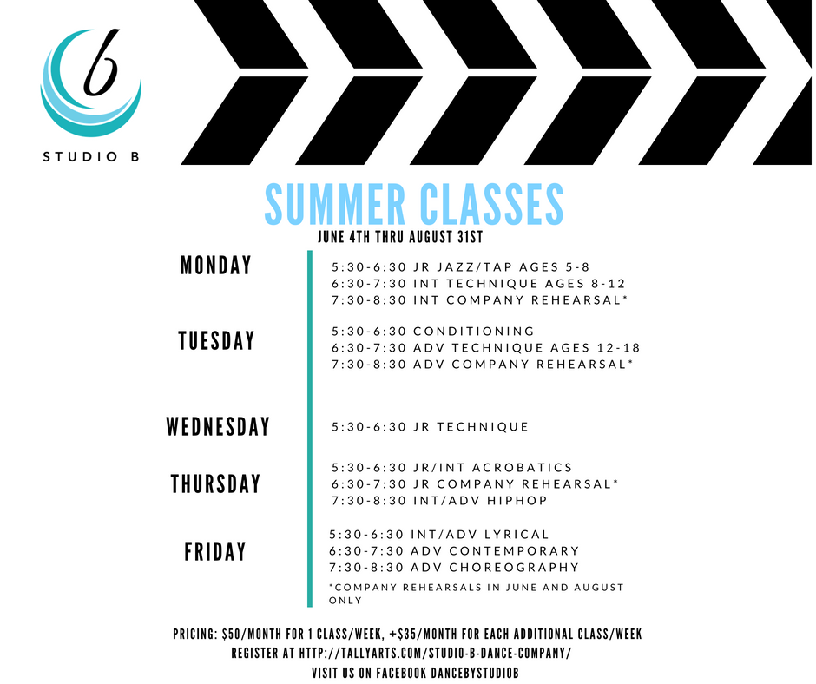**

**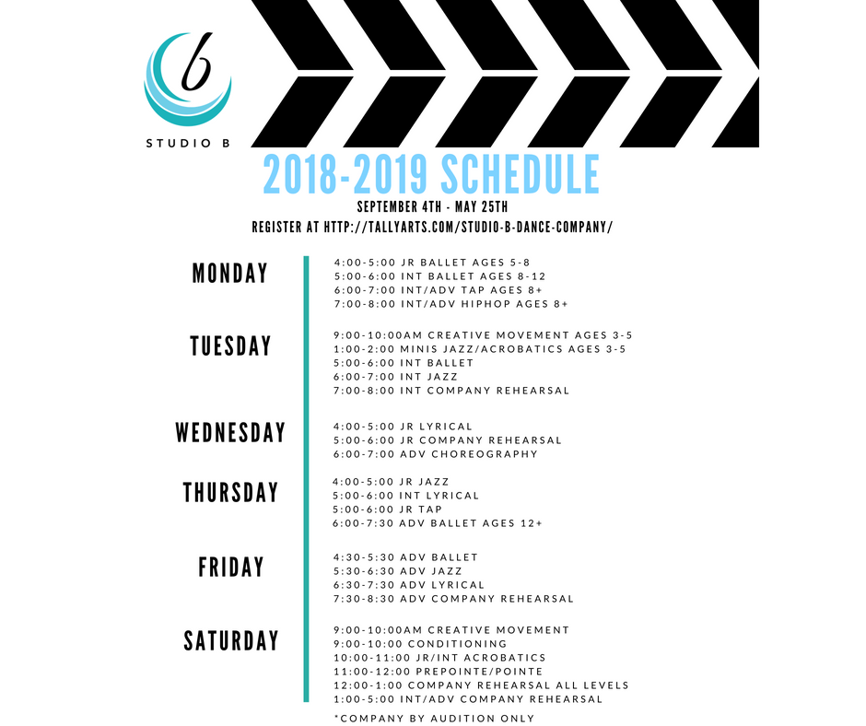**

**Overview of Company Commitments 2018-2019 and Policies**

We are a performance and competitive company. We will engage in local outreach performances within our community as well as a number of competitions over the course of the season. Company membership requires a year-long commitment and intense training. Though these commitments are relatively time-consuming, they are educational and intended for the benefit of your dancer and did I mention - they are FUN!!!

**Registration**: To register for classes, you must complete the online registration documents (print, sign and return the physical copy) and you must create a Procare account at [www.tallyarts.com](http://www.tallyarts.com). In addition, you must complete the attached class registration page.

**Company member class and rehearsal requirements**

**August 2018: All company members** despite level (junior, intermediate, advanced) are required to take their level’s technique class (jr ballet will be treated as the jr technique class), conditioning (jrs may take jr/int acro instead of conditioning), and their level’s company rehearsal. In addition, all company members must attend their Saturday production rehearsals in August (see attached calendar). Intermediate and Advanced company participating in Solos, Duets, and/or Trios must attend their Saturday solo/duet/trio rehearsals in August as well (see attached calendar).

**NOTE**: production rehearsal class and solo/duet/trio rehearsal class is treated as a regular class (price is +$25/month for production. If you are participating in any number of solos/duets/trios, you will also register for the +$25/month for solo/duet/trio class. Productions and solos/duets/trios will be rehearsal intensive during the months of August and September, but will be consolidated into a much shorter time slot by October and will continue that way for the remainder of the school year.

**School year class and rehearsal requirements \*School year schedule begins September 4th**

**Junior company:** must take ballet, jazz, jr company rehearsal, production rehearsal, and 1 class of their choosing (tuition $140/month)

**Intermediate company**: must take 2 ballet classes, jazz, intermediate company rehearsal, production rehearsal, and 1 class of their choosing. \*Optional solo/duet/trio rehearsal class subject to director approval (tuition $165-$190/month)

**Advanced company:** must take 2 ballet classes, jazz, lyrical, advanced company rehearsal, production rehearsal, and 1 class of their choosing. \*Optional solo/duet/trio rehearsal class subject to director approval. (tuition $190-$215/month)

**NOTE:** Dancers are always welcome and encouraged to take more than the required minimum number of classes for company. The more time spent in class and working in different genres of dance, the higher the quality of our company. Each additional class is +$25/month.

**Monthly tuition** is calculated by the number of classes a student takes each week. 1 class/week is $50/month. Each additional class/week is +$35/month. For example, if your student will be taking 3 classes/week, the tuition will be calculated as $50 + $35 + $35 = $120/month. Please note, tuition is due by the 5th of each month. Autodraft payments will be ran between the 1st and 5th of the month. Failure to pay tuition by the 5th of the month will result in a late payment fee of $10/day late. Returned payments (check or declined autodraft) will result in a returned payment fee of $25.

If your child misses class for whatever reason, they are invited to make up that class by attending one of the other classes offered for their level within a week of their absence. Due to the large number of classes we offer in our program, we will not schedule a private make-up class for absences nor will we pro-rate tuition. In the event a class is canceled by Miss Brittany, an alternative class from our program will be offered as a make-up class or under very extreme circumstances, a separate make-up class day will be scheduled. In addition, prorated tuition will not be offered during months with extended holidays.

School year registration is intended for a 10-month commitment (beginning September 4th and concluding May 31st). If at any time during this 10-month period, you elect to terminate services, we require a 30-day written notice. You will be accountable for any outstanding balance, as well as any tuition that accrues during the 30-day notice. Tuition, registration, recital, and costume fees are nonrefundable.

Private lessons are $30/hour and do not require a 10-month commitment, however private lesson tuition will be calculated for the entire month that your student is receiving private lessons. Private lesson students are invited, though not required to participate in our recital.

**Fundraising**: Whenever possible we will offer fundraising opportunities! These opportunities can help offset the cost of tuition, costumes, competition fees, etc. Once a fundraiser is completed – you will receive credit immediately to your account. Some fundraisers we have done in the past and will put on our schedule this season include Johnston’s Meat, Carwashes, Share Nights, and Bucket Drops. We are always looking for new fundraisers so please feel free to share your ideas! Please see the fundraising sheet in this packet and we will discuss fundraising more at our Welcome Party (see calendar).

**Code of Conduct:** Company members are expected to uphold a climate of positivity both in class and everywhere we go. Company members are the best representation of our program. I expect company members to set the example for our other students! Please go over the code of conduct on the following page with your dancer and sign/return.

**Communication:** Staying connected is imperative to receiving the most up to date information! Please make sure I have your phone number and email – and that it is an email you check daily. In addition, I have created a Studio B team on the app called Band. This will be my primary method of sending out videos, pictures, documents, and other important updates. **I expect all parents to use the Band app.** Dancers are encouraged to use the app as well to rehearse their dances and access their music. If you did not receive an invitation to the app, please contact me as soon as possible.

**STUDIO B DANCE COMPANY CODE OF CONDUCT CONTRACT**

**PURPOSE:** The purpose of the Studio B Dance Company is to provide students with an opportunity to engage in performances, develop sportsmanship and character, receive outside adjudication and participate in community outreach. Participation in Company is a privilege, not a right. As a member of the Company you represent our dance program; and your conduct and actions in the classroom, on the dance floor, and in the community should not deviate from the regulations and code of conduct set forth in our Code of Conduct. Company members must show determination, dedication, and desire to be a productive member of this company.

**CONDUCT RULES:**

**BE RESPECTFUL AND AGE APPROPRIATE.** We expect for our dancers to uphold age appropriate and respectful behavior at all times. Blaming, criticizing, correcting, bullying, and engaging in name calling or physical violence with fellow company members or other dancers at events the company attends – despite whether or not you intend such behaviors with malice – WILL NOT BE TOLERATED. If your actions are deemed inappropriate and disrespectful and do not coincide with this organization's guidelines you will be denied participation in this Company.

**ETIQUETTE AND BEHAVIOR**: In class and rehearsals, dancers must be fully engaged in executing the material being taught or reviewed. Talking, playing, sitting, cell phones and bad attitudes or other behavior disruptive to the team is prohibited. A dancer will be asked to leave in lieu of any other warning.

**DEDICATION**: There is a level of commitment required to be a part of the Company. You must have a desired level of commitment - not just for yourself, but for the ENTIRE company. Being in this company, you depend on all of your fellow company members to be at rehearsal consistently and do their part in having the knowledge of their routine. If at anytime you are not doing your part as a productive member of this company, you will be suspended from the Company.

**Dancers in Company will be supportive, courteous, and encouraging to each other and those around them at all times. Any person representing Studio B Dance Company will not speak negatively about our company, dancers, or those dancers and companies that we may come in contact with at performances, competitions, or other events. Creating a climate of positivity is imperative to building strong dancers and a strong company.**

**DISCIPLINARY ACTION**: Failure to follow the Studio B Dance Company Code of Conduct may result in, but is not limited to, the following actions:

• Probation in which the dancer is not allowed to perform any number of their dances during the probationary period \*NOTE: If a dancer violates or disregards any conditions listed in the Code of Conduct while already under probation, they will be removed from company immediately

• Removal from company

**REASONS FOR DISCIPLINARY ACTION**: The following situations will result in disciplinary action. There will be NO exceptions to these factors, so please read carefully.

• Attitude not promoting teamwork/sportsmanship.

• Lack of dedication/commitment being shown toward Company.

• Disregard for the code of conduct and the rules and guidelines governing this organization.

• Unexcused absences

• Lack of knowledge of a routine.

• Lack of improvement shown over time in a given routine.

• A dancer will not be allowed to practice/perform if an injury occurs for which that dancer is unable to perform at their normal level. Dancers will not be allowed to participate until written clearance is obtained from a doctor.

**REFUNDS**: Please be advised that any deposits/money put toward tuition, competition fees, uniforms, registration fees, recital fees or costume fees is NON-REFUNDABLE. This is regardless of whether a Company member is suspended from the team or not!

**PLEASE KEEP A COPY OF THE CODE OF CONDUCT AND TURN IN THE SIGNATURE PAGE BELOW**

---------------------------------------------------------------------------------------------------------------------------------------------

Company Member’s Name \_\_\_\_\_\_\_\_\_\_\_\_\_\_\_\_\_\_\_\_\_\_\_\_\_\_\_\_\_\_\_\_\_\_\_\_\_\_\_\_\_\_\_\_\_\_\_ I, the parent/guardian of the above named, have read the Studio B Dance Company Code of Conduct and understand all of the requirements in order for my dancer to continue team participation as well as the ramifications if this contract is broken.

\_\_\_\_\_\_\_\_\_\_\_\_\_\_\_\_\_\_\_\_\_\_\_\_\_\_\_\_\_\_\_\_\_\_\_\_\_\_\_\_\_\_\_\_\_\_\_\_\_\_\_\_\_\_\_\_

Parent/Guardian Signature/ Date

As a member of the Studio B Dance Company, I have fully read the Code of Conduct and understand what is expected of me to remain a member in good standing. I will keep myself knowledgeable and informed of all rules, and realize the consequences of poor behavior or inappropriate actions. I will do all I can to respect my fellow company members and teachers at all times.

\_\_\_\_\_\_\_\_\_\_\_\_\_\_\_\_\_\_\_\_\_\_\_\_\_\_\_\_\_\_\_\_\_\_\_\_\_\_\_\_\_\_\_\_\_\_\_\_\_\_\_

Company Member Signature/Date

**Other Expected Expenses**

**All students both company and noncompany**:

$55 annual registration fee; $27.50 sibling rate (per sibling)

$50 recital fee \*includes 2 recital tickets

$50 Costume Fee per the following classes and guidelines: ballet (only 1 costume fee for intermediate ballet, advanced ballet, and pointe/prepointe), jr jazz and jr tap (will use same costume – only 1 costume fee), intermediate jazz and int/adv tap (will use same costume- only 1 costume fee), adv jazz and int/adv tap (will use same costume – only 1 costume fee), jr lyrical, int lyrical, adv lyrical, creative movement, mini’s jazz/acro

\*HipHop and jr/int acrobatics will use dancewear from our class dresscode for their recital performances

\*Choreography and company rehearsal classes will use costumes from our wardrobe as rentals ($7.50 rental fee) or competition dances.

**Dresscode:**

All students must comply with the Studio B dresscode. The dresscode items are to be purchased directly by the parent on the discount dance website ([www.discountdance.com](http://www.discountdance.com)) where I have set up a dresscode list under Studio B Dance Company Arts Afterschool. Please use my teacher code (TP104454) to receive a discount. There are a few cheaper optional class leotards to choose from, however please make note of the required performance leotard, tights and shoes. The specific shoe and shoe color is less important in class, but will be required for all local performances, competitions, conventions, and our recital. All leotards to be worn in class must be selected from one of the approved (required or optional) leotards from the discount dance dresscode.

In addition, all classes (except ballet) must purchase jazz shorts with the studio b logo from our teamstore. Our teamstore link is [https://teamstore.gtmsportswear.com/StudioBDance](https://teamstore.gtmsportswear.com/StudioBDance" \t "_blank). The required item is the Groove short (~$30).

**Summary of Dresscode by Class**

**All classes leotards**

* **optional**: N5500 Adult Camisole Cotton Dance Leotard (turquoise - $12.95), N5500C Kids Camisole Cotton Dance Leotard (turquoise - $9.98), TH5527 Adult Triple Strap Tank Dance Leotard (turquoise - $19.95), TH5527C Child Triple Strap Tank Dance Leotard (turquoise - $18.95)
* **required**: N7264 Adult Emballe Lace Boatneck Tank Leotard (royal - $29.15), N7264C Child Emballe Lace Boatneck Tank Leotard (royal $27.32)

C**reative Movement/Jr Ballet/Int Ballet/Adv Ballet/Pre-pointe/Pointe**:

-Leotard (above)

-pink tights for in class (T5515 Adult Convertible Tights with Smooth Self-Knit Waistband $5.50 or T5515C Girls Convertible Tights with Smooth Self-Knit Waistband $4.50)

**-theatrical pink** tights for performances (A81 Adult totalSTRETCH Convertible Tights $11.17 or C81 Girls totalSTRETCH Convertible Tights $9.12)

-pink ballet shoes (T2915 Adult "SofTouch" Canvas Stretch Split-Sole Ballet Shoes $12.56 or T2915C Girls "SofTouch" Canvas Stretch Split-Sole Ballet Shoes $11.96)

-TH5109 Adult Sheer Wrap Skirt $12.95

**Mini’s Jazz/Acro/ Jr Jazz/ Int Jazz/ Adv Jazz**:

-Leotard (above), tan tights are optional for in class

-Groove short from our Teamstore (<https://teamstore.gtmsportswear.com/StudioBDance>)

**jazzy tan** tights for performances (A81 Adult totalSTRETCH Convertible Tights $11.17 or C81 Girls totalSTRETCH Convertible Tights $9.12)

**-tan** no-lace jazz shoes (T7602 Adult Gore Insert Jazz Boot $21.56 or T7602C Girls Gore Insert Jazz Boot $20.25)

**Jr Tap/ Int/ Adv Tap**: same as above, black tap shoes (T9555 Adult Split Sole Tap Shoes $32.36 or T9555C Child Split Sole Tap Shoes $26.66)

**Jr/Int Acro**: same as above (jazz), no shoes required

**Int/Adv HipHop and All Company Members**: same as above (jazz), T8000 Adult Split-Sole Sneaker $31.46 or T8000C Girls Split-Sole Sneaker $31.46

**Jr lyrical/ Int Lyrical/ Adv Lyrical/ Adv Choreography**: same as above (jazz), T8975 "Lyrical Flow" Canvas Closed-Toe Lyrical Shoes (**tan**)

**Company only**

\*Note: All fees such as those above and below (registration fee, recital fee, recital costume fee, competition fees, competition costumes for group dances, and school day off workshop/rehearsals) will be added together and divided over 10 monthly installments, to be paid in addition to tuition beginning September 1st and concluding June 1st. This year we will be including a coach’s fee for each competition/convention. This fee covers the cost of the coach’s travel expenses, choreography, and time spent organizing, planning, and executing all of the many tasks that go into directing a performance company/competitive team. This fee has been divided up equally amongst all company members for each competition/convention.

**Uniform**: Company membership will require a uniform that is worn for local performances, competitions and conventions. While you are on the Teamstore you can purchase the required leggings for our Company member uniform – the Groove ankle tights for $42. And you might find some other studio b merch that you and your dancer love! We love our company members and families to show their team spirit with tshirts, hats and bags. (Feel free to share the link with your friends and family!). To go with the the ankle tights, I will be ordering (separately) a performance tank and matching jacket. The tank and jacket will cost $125 and will be added to your payment plan. Remember that **you will be responsible for ordering the ankle tights on your own from the Teamstore** - this will not be included in your additional fee payment plan.

**Competition Costumes:** Whenever possible we will use costumes from our inventory that can be rented, though occasionally we must purchase new costumes. I have already planned which costumes we can use from our wardrobe and which costumes must be purchased. All company members will be renting at least 1 costume. As such, all members will be charged a flat $15 rental fee. The following are costumes that must be purchased:

* **Jr and Int group dance:** $25 (Meg, Ava, Hailey, Alex and Leilani already have this costume)
* **Int company dance:** $10
* **Adv company dance:** $15
* **Int and Adv group dance** (Meg, Ava, Hailey, Phoenix, Namitha, Reagan, Olivia, Livy and Emma only): $25
* **Livy and Olivia Duet:** $30

\*NOTE: I have picked rented costumes for all solos, duets, and trios with the exception listed above (Livy, Olivia). For solos, if you would prefer to purchase a new solo costume rather than using the rental suggestion, please notify me via email ASAP so that I can provide you options.

**Competition Fees:** All dancers are required to participate in 2 group dances. Solos, duets and trios are entirely optional and are open to intermediate and advanced company only. Please note the competition fees for each competition below, as well as the cast list of the dances we will be performing this season. **NOTE: all competitions/conventions are REQUIRED.**

**Radix Dance Competition and Convention**: We will not compete at Radix, but we will fully participate in the convention. This is a great opportunity to enhance our dancers’ training and ease them gently into the start of the competition season. The registration fee is $195 for juniors and $255 for intermediate/advanced. The coach’s fee is $140 per dancer. Thus, jr company members will be charged $335 and intermediate/advanced company members will be charged $395. Jr company parents will receive 1 observer ticket to accompany their child during the convention. Intermediate and Advanced company parents – please let me know if you would like to observe – the price for an observer ticket is $50.

**Showstoppers**: Solos $124, Duets/Trios $62, Group dances $52, Coach’s fee $125 per dancer

**KAR**: \*This event is optional for all company members – solo’s, duets/trios only – must RSVP by August 15th.

**Rainbow Regionals**: Solos $110, Duets/Trios $52, Group dances $46, Coach’s fee $143 per dancer

**Rainbow** **Nationals** Solos $126, Duets/Trios $65, Group dances $61, Coach’s fee $211 per dancer. \*Note: if accepted for the Disney Performance, we will not attend Nationals and will rewrite the additional fee payment to reflect any difference in fees

**Cast List**

**Advanced Company**

Reagan – solo, duet, trio, 2 group dances

Livy – solo, 2 duets, trio, 2 group dances

Olivia – solo, 2 duets, trio, 2 group dances

Emma – 2 solos, duet, trio, 2 group dances

**Intermediate Company**

Phoenix – solo, trio, 3 group dances

Hailey – solo, trio, 3 group dances

Namitha – 2 solos, trio, 3 group dances

Gracyn – solo, 2 group dances

Meaghyn – solo, trio, 4 group dances (Showstoppers 3 group dances; KAR solo and 1 group dance)

Ava - solo, trio, 4 group dances (Showstoppers 3 group dances; KAR solo and 1 group dance)

Bostyn – trio, 2 group dances

Katie – trio, 2 group dances

\*Sebastian: trio

**Junior Company**

Leilani – 2 group dances

Alex – 2 group dances

Lena – 2 group dances

Belle – 3 group dances (Showstoppers 2 group dances; KAR 1 group dance)

\*Elouise: 1 group dance (KAR, Rainbow, Nationals)

**School Day Off Workshops and Rehearsal Intensives** (all workshop fees **except** September 19th are included in year-round afterschool package) NOTE: All School Day Off Workshops and Rehearsal Intensives are MANDATORY

September 19th Acro workshop at Marty’s 9-12, rehearsal 12:30-5 **$40 \*this will be paid directly to Marty’s**

October 12th Workshop and Rehearsal 9a-5p **$40**

January 21st Workshop and Rehearsal 9a-5p **$40**

April 19th Workshop and Rehearsal 9a-5p **$40**

**Costumes and Dance Details**

Solos – Rentals – Pictured from left to right in the following order: \*Note: Livy “Creep” (lyrical) and Reagan “Already Gone” (lyrical) will be ordered as opposed to rented. Gracynn baton open solo will consult with Brittany.

Emma “I Ran” (contemporary) and “Na Na Na” (tap)

Olivia C “Jealous” (lyrical)

Meaghyn “Weak” (jazz)

Hailey “Don’t You Worry Child” (lyrical)

Phoenix “Bom Bom” (acro)

Namitha \*Song to be selected (musical theater)

Ava “Resolve” (contemporary)

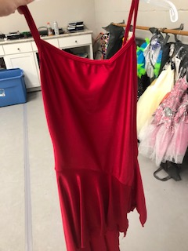 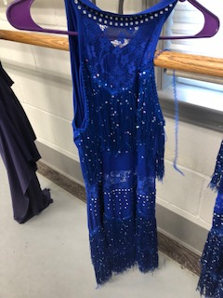 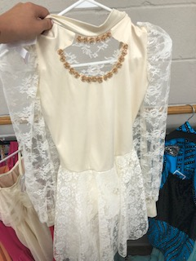 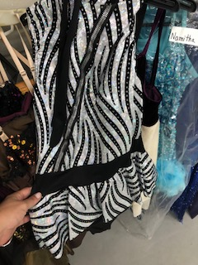 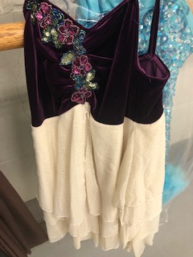 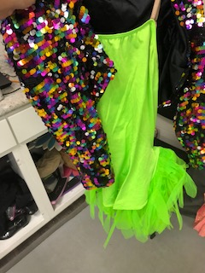 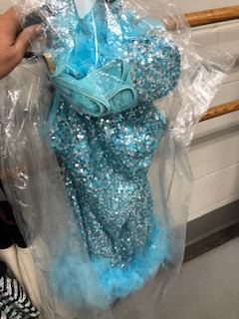 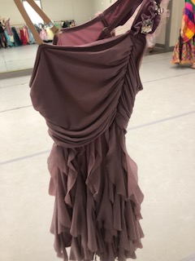

Duets – Pictured from left to right in the following order: Rea/Livy “Lovely” (contemporary), Emma/Olivia “All I Want” (lyrical), Livy/Olivia “Lights Go Out” (\*will purchase $30)

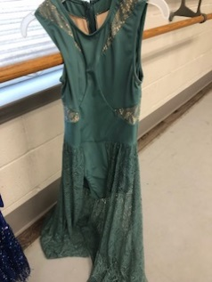 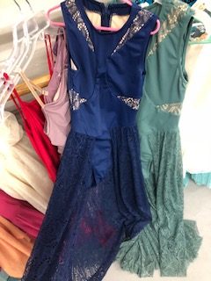 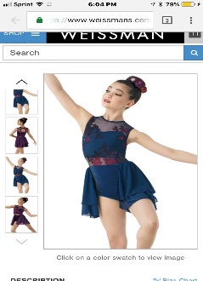

Trios: Pictured from left to right in the following order: Katie/Bostyn/Sebastian “Bang Bang” (hiphop), Phoenix/Hailey/Olivia C “Extraordinary Machine” (open), Reagan/Emma/Livy “Stand by Me” (lyrical), Meaghyn/Namitha/Ava “All About That Bass” (jazz)

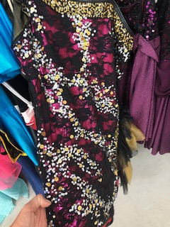 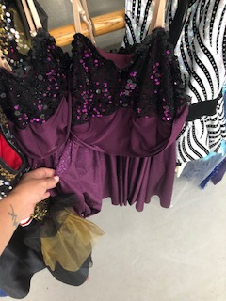 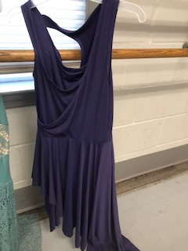 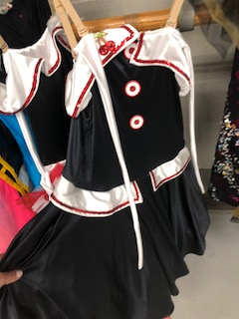

Groups: Pictured from left to right in the following order: Jr (Lena, Belle, Alex, Leilani) “Boogie Woogie Bugle Boy” (jazz), Int (Bostyn, Katie, Gracynn, Ava, Namitha, Phoenix, Hailey, Meaghyn) “Sunshine” (lyrical) \*purchase $10, Adv (Emma, Reagan, Livy, Olivia) “La La La” (lyrical) \*purchase $15, Jr/Int (Lena, Belle, Alex, Leilani, Bostyn, Katie, Gracynn, Ava, Namitha, Phoenix, Hailey, Meaghyn) “No Excuses” (jazz) \*purchase for those that do not own it already $25, Int/Adv “You Should See Me in a Crown” (Ava, Namitha, Phoenix, Hailey, Meaghyn, Emma, Reagan, Livy, Olivia) contemporary \*purchase $25

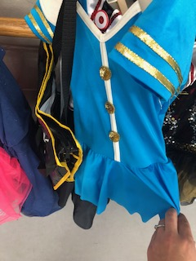 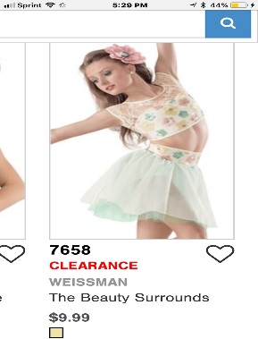 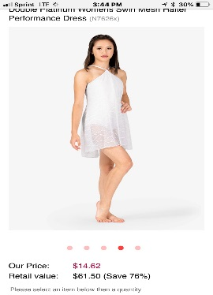 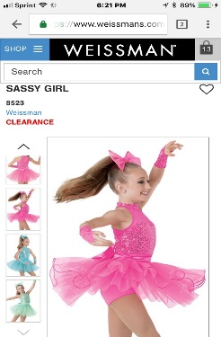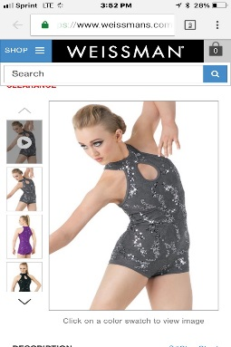

**Fundraising Events – If discrepancies go by the Official Company Calendar (NOT this calendar)**

I have reached out to several restaurants and businesses about share nights. As I receive confirmations, I will add these to the calendar. Here is a list of businesses I’ve contacted: Chipotle, Which Wich, Smashburger, Red Elephant, Nuberri, Moes, Sweet Frog (for both a share night and giftcards to sell – we can attach these to our carwashes), Krispy Kreme (to sell gift certificates or preorder dozens of donuts), Skate World, SkyZone, Zaxby’s, Texas Roadhouse, Panera, Maple Street Biscuit Company, Sonnys BBQ, Burger Fi, Island Wings, and Dave’s. The goal is to do 2-3 fundraisers every month. Share nights are easy for everyone as they do not require any actual work. The biggest way to have success is to make sure our marketing is in place to share the events (flyers, social media) and tell all your friends and family – I will have flyers, tickets and fb posts for you to share with everyone and most places want your share night supporters to show either the fb post or the flyer (instead of simply mentioning studio b). Do take note of the schedule of fundraising events below. To make sure every family gets the most out the fundraising, certain fundraisers will be delegated to certain company levels – others will be for everyone. There will be some events that require everyone to pitch in. We will begin organizing these at our Welcome Party. Note: once funds have been received for a fundraiser, they will be immediately credited to your dancers account (i.e. this means fundraising can offset anything from tuition, to fees, costumes, uniforms, etc).

**July 27-28: All Night Party Lock-in**: We will host a lock-in at Arts for ages 5+. ADV company. We will do a couple crafts, outside water play, inside games, dance party, dance class, ice cream bar and pizza, movies and breakfast the next morning.

**August 25th 4p-8p Panera Bread** Share Night #1: proceeds will benefit Jr company members

**August 31st: Back To School Lock-in**: Same idea as above. By offering this event a second time, we can correct any issues we had with the first lock-in and we should be able to see if this is a fundraiser worth doing again in the future. \*\*I will add more Lock-Ins to the Calendar – Make sure you use the Band app!

**September 8th 4p-8p Chipotle** Share Night #2: proceeds will benefit Intermediate company members

**September 15th 9am-2pm CarWash**: We will presell tickets and also will include Sweet Frog giftcards in the price of the Carwash. For $20, a customer would get a carwash, a back massage, and a $5 Sweet Frog giftcard. Customers can either pay in advance with a ticket or pay at the event. Everyone that either sells tickets or works at the carwash will receive credit.

**September 27th-30th BurgerFi** Share Night #3: proceeds will benefit Adv company members. We will be given coupons to hand out – for each coupon redeemed over these dates, we will receive $2.

**October (requested dates are 10/6, 10/7, 10/13, 10/14) Skyzone**: Proceeds will benefit Advanced company

**October 27th Fall Festival**: This is our first BIG event. We will coordinate with Arts to provide carnival games outside, activities in each room of the facility (example we could decorate the dance room as a haunted house/maze), invite food trucks, raffle off door prizes, hold a costume contest, and we can do Trunk or Treat in the parking lot (we could also have a contest for best trunk). We might even invite a band or two and have our company perform a few dances. Proceeds will benefit everyone that contributes.

**November 1st Skate World 4p-8p**: proceeds will benefit Intermediate company

**November 16th Johnston Meat Delivery**: We will take orders from October 15th through November 9th. This has always been a great fundraiser for us. We are taking advantage of the upcoming Thanksgiving Holiday. The more meat you sell the more proceeds your dancer receives.

**Late November/early December WalMart Bucket Drops TBA**

**December 4th Sonnys BBQ time TBA** Share Night #4: proceeds will benefit Jr company

**December Zaxby’s date TBA** Share Night #5: proceeds will benefit Int company

**January Share Night #6 TBA**: proceeds will benefit Adv company

**January Krispy Kreme**: we will either sell gift certificates or presell boxes of donuts. The more you sell the more your dancer receives.

**February Share Night #7** TBA: proceeds will benefit Jr company

**February 16th (tentative) Daddy Daughter Ball Sock-Hop**: Another big event that will take the whole company to plan. We will decorate the back yard with tents and tables and use the concrete stage as the dance floor. We will offer food included in the ticket price and we will presell tickets. Proceeds will benefit all that contribute.

**March Share Night #8**: proceeds benefit Int company

**March Share Night #9**: proceeds benefit Adv company

**April 13th Jr Chef Competition**: Big event to coordinate! We will break participants into teams that will be coached by Chefs. Participants will be charged an entry fee. We will also charge tickets for observers and have the event catered by a sponsor. Judges can be sponsors? Proceeds benefit all that sell tickets and/or work the event. We can donate the meals prepared by the teams to a local shelter?

**April 19th Johnstons Meat Delivery**: We will take orders from March 18 through April 12th. Same as the fall Johnstons meat fundraiser.

**May Share Night #10** TBA: proceeds benefit Jr company

**May 11th Craft Morning, Parent’s morning out**: Adv company will lead mothers day crafts and proceeds will benefit Adv company

**May 31 Recital Rehearsal Pizza**: Proceeds will benefit Int company

**June 1 Recital Flower sales**: Proceeds will benefit all

**June-August 2019**: We will book 1 share night and 1 lock-in (if proven successful) each month over the summer.

\*\*\*Sponsorships: I will be getting those sponsorship letters done before our Fall schedule begins. This fell to the back burner last season but I am making it a priority for the new season. Once I have the sponsorship letter complete I will ask your help in soliciting organizations and businesses to sponsor us. Sponsors will likely receive a Studio B tshirt or other merchandise, perhaps we make a shirt that lists our sponsors on the back, tickets to our recital or other events, and ad space in our recital program.

**Company Calendar**

\*NOTE: This calendar may change slightly so use the Band app regularly. Will add a performance benefitting the Tallahassee Senior Center (not listed on Calendar).

**-Friday July 27th 6p- Saturday July 28th 9am:** Party All-Night Lock-In

**-Saturday August 4th Rehearsals 10am-6pm**

* 10a-11:30a: Emma solo
* 11:30a-1:30p: Meaghyn, Ava and Namitha trio
* 1:30p-3p: Olivia C and Livy duet
* 3p-4p: Meaghyn solo
* 4p-5p: Olivia C solo
* 5p-6p: Ava solo

**-Saturday August 11th Rehearsals 11a-3p AND Company Welcome Party 4p Dave’s Pizza Garage**

* 11a-12p Intermediate and Advanced Company group dance
* 12p-1p: Meaghyn, Ava and Namitha trio
* 1p-2p: Reagan and Livy duet
* 2p-3:30p: Phoenix, Hailey, and Olivia C trio
* **4pm Welcome Party and Parent Meeting!**

**-Saturday August 18th Rehearsals 10am-6pm AND FALL REGISTRATION 2p-6p**

* 10am-11:30am Junior and Intermediate Company group dance
* 11:30am-12:30p Meaghyn solo
* 12:30p-2p: Hailey solo
* 2p-3:30p: Phoenix solo
* 3:30p-4:30p Olivia C solo
* 4:30p-6p Livy solo

**-Saturday August 25th Rehearsals 10am-6pm and Panera Bread Share Night for Jr company 4p-8p**

* 10a-11:30am Junior and Intermediate Company group dance
* 11:30am-12:30p Reagan and Livy duet
* 12:30pm-2:30p All companies: local performance pieces
* 2:30p-4p: Olivia C and Emma duet
* 4p-5p: Reagan solo
* 5p-6p: Emma solo

**-Saturday September 1st – Monday September 3rd NO CLASS OR REHEARSAL Labor Day Weekend**

**-Tuesday September 4th Fall Schedule begins!**

**-Saturday September 8th Rehearsal 12p-5p and Chipotle Share Night for Int company 4p-8p**

* 12p-1p All companies: local performance pieces
* 1p-2p: Intermediate and Junior company group dance
* 2p-3p: Intermediate and Advanced company group dance
* 3p-5p: Olivia and Livy duet

**-Saturday September 15th No Rehearsal and CarWash Fundraiser 9am-2pm**

**-Wednesday September 19th Fall Holiday (no school or regular class):**

* Acro workshop at Marty McQueen’s 9a-12p
* Rehearsal for all companies 12:30-6p
  + Rehearse performance pieces 12:30-2:30
  + Finish int/adv and jr/int group dances 2:30-4:30
  + Emma, Reagan, Livy Trio 4:30-6

**-Friday September 21st Time TBA: Northtown Getdown Performance at Bannerman Crossing**

**-Saturday September 22nd Rehearsals 12pm-6pm**

* 12p-1p Jr/Int group dance
* 1p-2p Int/Adv group dance
* 2p-3p Run all dances
* 3p-4:30p Olivia C, Phoenix, Hailey Trio
* 4:30p-6p Emma, Reagan, Livy Trio

**-September 27th-September 30th BurgerFi Sharenight for Adv company**

**-Saturday September 29th Rehearsals 12p-6p All Solo’s**

**-October 6,7, 13, 14th Skyzone Share Night (Specific date TBA) for Advanced Company**

**-Saturday October 6th Rehearsals 12p-4p All companies**

* 12p-2p Local performance pieces
* 2p-4p Run all Competition pieces

**-Friday October 12th (Teacher Planning Day No school or Regular class) Workshop/Rehearsal 9a-6p**

* Workshop 9a-12p
* Local performance pieces 12:30-3
* Perform competition and local performance pieces for Afterschool day camp 3:30-5p

**-Saturday October 13th Rehearsal 12p-2p All company**

* **2p-3p Meg/Ava/Belle/Elouise**

**-Monday October 15th thru November 3rd Collect Johnston Meat Orders**

**-Friday October 19th Northtown Getdown Performance time TBA**

**-Saturday October 20th Rehearsals 12p-2p All company**

* **2p-3p Meg/Ava/Belle/Elouise**

**-Saturday October 27th No Rehearsal \*\*Fall Festival Fundraiser 4p-8p\*\***

**-Thursday November 1 Skate World Share Night 4p-8p for Intermediate Company**

**-Saturday November 3rd Rehearsal 12p-2p All companies \*\*Johnston Meat Orders Due!**

* **2p-3p Meg/Ava/Belle/Elouise**

**-Friday November 9th thru Sunday November 11th Radix Dance Convention**

**-Monday November 12th NO CLASSES**

**-Friday November 16th Johnston Meat Pickup**

**-Saturday November 17th Rehearsal 12p-4p All company \*Competition and Performance pieces**

**-Monday November 19th-Sunday November 25th NO CLASSES OR REHEARSALS (Thanksgiving Break)**

**-Friday November 30th Celebration of Lights Rehearsal 6p-8p**

**-Saturday December 1st Celebration of Lights Performance Time TBA (No rehearsal)**

**-Tuesday December 4th Sonny’s BBQ Share Night for Jr Company (Dick Wilson BLVD)**

**-Saturday December 8th Rehearsal 12p-2p and Walmart Bucket Drop 4p-8p (multiple locations?)**

* **2p-3p Meg/Ava/Belle/Elouise**

**-Friday December 14th Winter Demonstration at Arts (Tentative-TBA)**

**-Saturday December 15th No Rehearsal – Company Holiday Party and Zaxby’s Share Night for Intermediate Company**

**-Wednesday December 19-Friday December 21st Early Release Days and Saturday December 22nd \*Classes will meet!**

**-Monday December 24th-Monday January 7th No Classes or Rehearsals \*Winter Break**

**-Saturday January 5th and Sunday January 6th Weekend Workshop TBA \*\*Krispy Kreme Donut Fundraiser**

**-Tuesday January 8th Classes Resume**

**-Saturday January 12th Rehearsal 12p-2p All company**

* **2p-3p Meg/Ava/Belle/Elouise**

**-Saturday January 19th Rehearsal 12p-3p All company (including Elouise) and Share Night for Adv (TBA)**

**-Monday January 21st MLK School Day Off Workshop and Rehearsal 9a-6p (No regular classes)**

* Workshop 9a-12p
* 12:30p-5p Rehearsal

**-Saturday January 26th Rehearsal 12p-2p All company and Share Night for Jr company (TBA)**

**-Friday February 1st – Sunday February 3rd Showstoppers Dance Competition All company**

**-Saturday February 9th Competition Review 12p-2p All company**

**-Saturday February 16th No Rehearsal and Daddy/Daughter Ball Fundraiser**

**-Saturday February 23rd Rehearsal 12p-2p All company**

**-Saturday March 2nd Rehearsal 12p-2p All company and Share Night for Int company (TBA)**

**-Saturday March 8th Rehearsal 12p-2p All company**

**-Saturday March 16th No Rehearsal and Share Night for Adv company (TBA)**

**-Monday March 18th-Monday March 25th NO CLASS OR REHEARSAL SPRING BREAK**

* \*\*Take orders for Johnston Meat (March 18th thru April 6th)

**-Friday March 22-Sunday March 24th KAR Dance Competition (optional)**

**-Saturday March 30th Rehearsal 12p-4p All Company (competition and performance pieces)**

**-Saturday April 6th No Rehearsal**

* Orders due for Johnston Meat
* Springtime Tallahassee Performance time TBA

**-Saturday April 13th No Rehearsal and Jr Chef Competition Fundraiser**

**-Thursday April 18th Johnston Meat Pickup**

**-Friday April 19th Spring Holiday – School Day Off Workshop and Rehearsal 9a-6p**

* 9a-12p Workshop
* 12:30p-5p Rehearsal

**-Saturday April 20th Rehearsal 12p-2p All Company**

**-Saturday April 27th Rehearsal 12p-4p All Company and Sleepover Party!!**

**-Friday May 3-Sunday May 5th Rainbow Dance Competition**

**- Saturday May 11th Craft Morning Fundraiser – Adv company and Competition Review 12p-2p All**

**-Saturday May 18th No Rehearsal – Recital Picture Day – Performance at Agape Dance Ministry TBA**

**-Saturday May 25th Rehearsal and Recital finale 12p-4p All company**

**-Friday May 31st Recital Dress Rehearsal Lee Hall Auditorium**

* Jr company pizza fundraiser at rehearsal

**-Saturday June 1st Recital at Lee Hall Auditorium 10:30am**

* Int company Flower Fundraiser at Recital

**-Monday June 3rd Summer Schedule begins**

**-June 27th thru July 2nd Rainbow Nationals (tentative)**

**Class Registration**

Student’s Name: \_\_\_\_\_\_\_\_\_\_\_\_\_\_\_\_\_\_\_\_\_\_\_\_\_\_\_\_\_\_\_ Date of Birth (MM/DD/YYYY): \_\_\_\_\_\_\_\_\_\_\_\_\_\_

Mailing Address: \_\_\_\_\_\_\_\_\_\_\_\_\_\_\_\_\_\_\_\_\_\_\_\_\_\_\_\_\_\_\_\_\_\_\_\_\_\_\_\_\_\_\_\_\_\_\_\_\_\_\_\_\_\_\_\_\_\_\_\_\_\_\_\_\_\_\_\_\_\_

Primary Phone: \_\_\_\_\_\_\_\_\_\_\_\_\_\_\_\_\_\_\_\_\_\_\_\_\_\_\_\_\_\_\_\_ Phone (2): \_\_\_\_\_\_\_\_\_\_\_\_\_\_\_\_\_\_\_\_\_\_\_\_\_\_\_\_\_

Parent(s) Name: \_\_\_\_\_\_\_\_\_\_\_\_\_\_\_\_\_\_\_\_\_\_\_\_\_\_\_\_\_\_\_\_\_\_\_\_\_\_\_\_\_\_\_\_\_\_\_\_

Anticipated Method of Payment: ACH Autodraft\_\_\_\_ Credit Card\_\_\_\_ Cash/Check\_\_\_\_ Credit Card\_\_\_\_

Credit card Information if applicable:

Name on Card \_\_\_\_\_\_\_\_\_\_\_\_\_\_\_\_\_\_\_\_\_\_\_\_\_\_\_\_\_\_

Billing address \_\_\_\_\_\_\_\_\_\_\_\_\_\_\_\_\_\_\_\_\_\_\_\_\_\_\_\_\_\_

Card Number \_\_\_\_\_\_\_\_\_\_\_\_\_\_\_\_\_\_\_\_\_\_\_\_\_\_\_\_\_\_\_ Card expiration \_\_\_\_\_ CVV/Security code \_\_\_\_\_

**Parent Contact Information**

Primary Email Address: \_\_\_\_\_\_\_\_\_\_\_\_\_\_\_\_\_\_\_\_\_\_\_\_\_\_\_\_\_\_\_\_\_\_\_\_\_\_\_\_\_\_\_\_\_\_\_\_\_\_\_\_\_\_\_\_\_\_\_\_\_\_\_\_\_

Primary Phone # \_\_\_\_\_\_\_\_\_\_\_\_\_\_\_\_\_\_\_\_\_\_\_\_\_\_\_\_\_\_

**Emergency Contact Information**

Name \_\_\_\_\_\_\_\_\_\_\_\_\_\_\_\_\_\_\_\_\_\_\_\_\_\_\_\_\_\_\_\_\_\_\_\_\_\_\_\_\_\_\_ Relationship to dancer \_\_\_\_\_\_\_\_\_\_\_\_\_\_\_\_\_\_\_\_\_\_\_

Phone Number \_\_\_\_\_\_\_\_\_\_\_\_\_\_\_\_\_\_\_\_\_\_\_\_\_\_\_\_\_\_\_\_\_\_\_\_

**Legal Release and Policy Acceptance (please initial)**

\_\_\_ I/we understand the Studio Policies outlined in the Company Handbook including billing obligations, risks related to dance, class dress code, class schedule, attendance policy, responsibilities for my property, company requirements and code of conduct (if applicable). I/we have completed the required ProCare registration online.

\_\_\_\_\_\_\_\_\_\_\_\_\_\_\_\_\_\_\_\_\_\_\_\_\_\_\_\_\_\_\_\_\_\_\_ \_\_\_\_\_\_\_\_\_\_\_\_\_\_\_\_\_\_\_\_\_\_\_\_\_\_\_\_\_\_

Signature / Responsible Party Date

**Measurements**

\_\_\_\_ Height \_\_\_ Girth \_\_\_ Bust \_\_\_ Clothing size

\_\_\_\_ Shoe Size \_\_\_ Inseam \_\_\_ Waist \_\_\_ Hips

**Medical**

Allergies: \_\_\_\_\_\_\_\_\_\_\_\_\_\_\_\_\_\_\_\_\_\_\_\_\_\_\_\_\_\_\_\_\_\_\_\_\_\_\_\_\_\_\_\_\_\_\_\_\_\_\_\_\_\_\_\_\_\_\_\_\_\_\_\_\_\_\_\_\_\_\_\_\_\_\_\_

Will your child require any special medical attention during a normal class: (yes/no) \_\_\_\_\_\_\_\_\_\_\_\_\_\_\_\_\_\_

If yes – Explain: \_\_\_\_\_\_\_\_\_\_\_\_\_\_\_\_\_\_\_\_\_\_\_\_\_\_\_\_\_\_\_\_\_\_\_\_\_\_\_\_\_\_\_\_\_\_\_\_\_\_\_\_\_\_\_\_\_\_\_\_\_\_\_\_\_\_\_\_\_\_\_

**Classes: Please place a check next to the classes for which you are registering for August.**

|  |  |  |
| --- | --- | --- |
| Class Name | Meeting Day/ Time | August |
| Junior Jazz/Tap ages 5-8 | Monday 5:30-6:30 |  |
| Intermediate Technique ages 8-12 | Monday 6:30-7:30 |  |
| Intermediate Company Rehearsal | Monday 7:30-8:30 |  |
| Conditioning ages 5+ (company); ages 8+ if general | Tuesday 5:30-6:30 |  |
| Advanced Technique ages 12+ | Tuesday 6:30-7:30 |  |
| Advanced Company Rehearsal | Tuesday 7:30-8:30 |  |
| Jr Ballet | Wednesday 5:30-6:30 |  |
| Junior/Intermediate Acrobatics ages 5-12 | Thursday 5:30-6:30 |  |
| Junior Company Rehearsal | Thursday 6:30-7:30 |  |
| Intermediate/Advanced HipHop ages 8+ | Thursday 7:30-8:30 |  |
| Intermediate/Advanced Lyrical ages 8+ | Friday 5:30-6:30 |  |
| Advanced Contemporary ages 12+ | Friday 6:30-7:30 |  |
| Advanced Choreography ages 12+ | Friday 7:30-8:30 |  |
| Saturday Production Rehearsal (All) | Saturdays per Calendar |  |
| Saturday Solo/Duet/Trio Rehearsal (Int and Adv) | Saturdays per Calendar |  |

**August 2018: All company members** despite level (junior, intermediate, advanced) are required to take their level’s technique class (jr ballet will be treated as the jr technique class), conditioning (jrs may take jr/int acro instead of conditioning), and their level’s company rehearsal. In addition, all company members must attend their Saturday production rehearsals in August (see attached calendar). Intermediate and Advanced company participating in Solos, Duets, and/or Trios must attend their Saturday solo/duet/trio rehearsals in August as well (see attached calendar).

**1st class is $40/month**

Number of additional classes at +$25/month \_\_\_\_\_\_\_\_

Total tuition for August \_\_\_\_\_\_\_\_\_\_\_\_

**Classes: Please place a check next to the classes for which you are registering. \*September-May**

**Student Name\_\_\_\_\_\_\_\_\_\_\_\_\_\_\_\_\_\_\_\_\_\_\_\_\_\_\_\_\_\_\_\_\_\_\_\_\_\_\_\_\_\_\_\_\_\_\_\_\_\_\_\_\_\_\_\_**

|  |  |  |
| --- | --- | --- |
| Class Name | Meeting Day/ Time | Check |
| Junior Ballet ages 5-8 | Monday 4-5 |  |
| Intermediate Ballet ages 8-12 | Monday 5-6 |  |
| Intermediate/Advanced Tap ages 8+ | Monday 6-7 |  |
| Intermediate/Advanced HipHop ages 8+ | Monday 7-8 |  |
| Creative Movement ages 3-5 | Tuesday 9a-10a |  |
| Mini’s Jazz/Acrobatics ages 3-5 | Tuesday 1-2 |  |
| Intermediate Ballet ages 8-12 | Tuesday 5-6 |  |
| Intermediate Jazz ages 8-12 | Tuesday 6-7 |  |
| Intermediate Company Rehearsal | Tuesday 7-8 |  |
| Junior Lyrical ages 5-8 | Wednesday 4-5 |  |
| Junior Company Rehearsal | Wednesday 5-6 |  |
| Advanced Choreography | Wednesday 6-7 |  |
| Junior Jazz ages 5-8 | Thursday 4-5 |  |
| Intermediate Lyrical ages 8-12 | Thursday 5-6 |  |
| Junior Tap ages 5-8 | Thursday 5-6 |  |
| Advanced Ballet ages 12+ | Thursday 6-7:30 |  |
| Advanced Ballet | Friday 4:30-5:30 |  |
| Advanced Jazz | Friday 5:30-6:30 |  |
| Advanced Lyrical | Friday 6:30-7:30 |  |
| Advanced Company Rehearsal | Friday 7:30-8:30 |  |
| Creative Movement ages 3-5 | Saturday 9a-10a |  |
| Conditioning ages 5+ | Saturday 9a-10a |  |
| Junior/Intermediate Acrobatics ages 5-12 | Saturday 10a-11a |  |
| Prepointe/Pointe ages 12+ | Saturday 11a-12p |  |
| Company Production Rehearsal | Saturday 12-1 |  |
| Company Solos/Duets/Trios Rehearsal | Saturday 1-5 |  |

\* Advanced Choreography requires enrollment in at least 1 other Studio B class

**Company member (circle): Yes No**

**Pricing**

General $50/month for 1 class/week; +$35/month per additional class

Company $40/month for 1 class/week; +$25/month per additional class; +$25/month per Rehearsal class

Tuition Total:\_\_\_\_\_\_\_\_\_\_\_\_\_/month

**Additional Fee Payment Plan Worksheet**

**Annual Registration Fee**: \_\_$55 single student OR \_\_$27.50 sibling rate (per sibling)

**Recital Fee**: \_\_$50 per student

**Recital Costume Fee**: $50 per class

\_\_ ballet (only 1 costume fee for intermediate ballet, advanced ballet, and pointe/prepointe)

\_\_ jr jazz and jr tap (will use same costume – only 1 costume fee)

\_\_ intermediate jazz and int/adv tap (will use same costume- only 1 costume fee)

\_\_ adv jazz and int/adv tap (will use same costume – only 1 costume fee),

\_\_ jr lyrical

\_\_ int lyrical

\_\_ adv lyrical

\_\_ creative movement

\_\_ mini’s jazz/acro

**Recital costume deposit $100 (will go to Jazz/tap and ballet)**

Remaining recital costume fees \_\_\_\_\_\_

**Competition Costume Rental Fee $15**

**\_\_\_\_ Jr/Int Jazz $25 (Gracynn, Namitha, Bostyn, Katie, Lena)**

**\_\_\_\_ Livy/Olivia Duet $30**

**\_\_\_\_ Int lyrical $10 (Gracynn, Namitha, Bostyn, Katie, Meaghyn, Phoenix, Hailey)**

**\_\_\_\_ Adv lyrical $15 (Emma, Reagan, Livy, Olivia)**

**\_\_\_\_ Int/Adv contemporary $25 (Namitha, Meaghyn, Phoenix, Hailey, Emma, Reagan, Livy, Olivia)**

**Total competition costume fees \_\_\_\_\_\_\_\_\_\_\_\_**

**Uniform tank top and jacket $125**

**\*\*Indicate the number of dances which your dancer will be performing in at each competition**

**Radix Dance Competition and Convention**:

\_\_\_ convention fee $305 jr company \_\_\_ $365 convention fee for int and adv company \_\_\_$50 observer

**Showstoppers** \_\_\_Solo ($124) \_\_\_ Duet/Trio ($62) \_\_\_ Group dances ($52) \*Coach Fee ($125)

\_\_\_\_\_\_\_\_ Showstopper Total

**Rainbow Regionals** \_\_\_\_Solo ($110) \_\_\_\_ Duet/Trio ($52) \_\_\_\_Group dances ($46) \*Coach Fee ($143)

**\_\_\_\_\_\_\_\_\_**Rainbow Total

**Rainbow** **Nationals** \_\_\_\_Solo ($126) \_\_\_\_ Duet/Trio ($65) \_\_\_Group dances ($61) \*Coach Fee ($211)

**\_\_\_\_\_\_\_**Rainbow Nationals Total

**Total competition fees $\_\_\_\_\_\_\_\_\_\_\_**

**School Day Off Workshops and Rehearsal Intensives (Oct 12, Jan 21 and April 19 workshops included in price of year-round Arts Afterschool program participants)**

\_\_\_ October 12th Workshop and Rehearsal 9a-5p **$40**

\_\_\_ January 21st Workshop and Rehearsal 9a-5p **$40**

\_\_\_ April 19th Workshop and Rehearsal 9a-5p **$40**

**Total school day off workshop/intensive fees $\_\_\_\_\_\_\_\_\_\_\_**

**Total of all Additional Fees $\_\_\_\_\_\_\_\_\_\_\_\_\_\_\_ 10% (processing and merchant fee) \_\_\_\_\_**

**Total Additional fees and 10% processing fee \_\_\_\_\_\_\_\_\_\_\_ Divide by 10 months \_\_\_\_\_\_\_\_\_\_**

**This is your payment plan amount to be paid each month from September 2018 through June 2019 in addition to your monthly tuition. Please note, you will be required to place a check or credit card on file that will be charged for the full amount in the event the installment total is not paid monthly or if you or Studio B terminate services (class or company membership).**

**Monthly Tuition** \_\_\_\_\_\_\_\_\_\_\_\_\_\_\_ **Monthly Payment Plan \_\_\_\_\_\_\_\_\_\_\_\_\_\_**

**Schedule Conflicts**

Do you have any scheduling conflicts that we need to be aware of? \*Please note this does not mean we can avoid them, but we will try where we can. Please understand that Studio B commitments – as a company member – should be given priority over other activities and commitments. Dancers must attend all competitions/conventions. All company-required classes, rehearsals, performances and fundraisers are considered mandatory; however, each dancer will be allowed 3 excused (prior notice or illness) and 2 unexcused absences over the course of the season. "Prior notice" will require at least 4 weeks in advance notification via email! List any known schedule conflicts below:

\_\_ \_\_\_\_\_\_\_\_\_\_\_\_\_\_\_\_\_\_\_\_\_\_\_\_\_\_\_\_\_\_\_\_\_\_\_\_\_\_\_\_\_\_\_\_\_\_\_\_\_\_\_\_\_\_\_\_\_\_\_\_\_\_\_\_\_\_\_\_\_\_\_\_\_\_\_\_\_\_\_\_\_\_\_\_\_\_\_\_\_\_\_

\_\_\_\_\_\_\_\_\_\_\_\_\_\_\_\_\_\_\_\_\_\_\_\_\_\_\_\_\_\_\_\_\_\_\_\_\_\_\_\_\_\_\_\_\_\_\_\_\_\_\_\_\_\_\_\_\_\_\_\_\_\_\_\_\_\_\_\_\_\_\_\_\_\_\_\_\_\_\_\_\_\_\_\_\_\_\_\_\_\_\_

\_\_\_\_\_\_\_\_\_\_\_\_\_\_\_\_\_\_\_\_\_\_\_\_\_\_\_\_\_\_\_\_\_\_\_\_\_\_\_\_\_\_\_\_\_\_\_\_\_\_\_\_\_\_\_\_\_\_\_\_\_\_\_\_\_\_\_\_\_\_\_\_\_\_\_\_\_\_\_\_\_\_\_\_\_\_\_\_\_\_\_

\_\_\_\_\_\_\_\_\_\_\_\_\_\_\_\_\_\_\_\_\_\_\_\_\_\_\_\_\_\_\_\_\_\_\_\_\_\_\_\_\_\_\_\_\_\_\_\_\_\_\_\_\_\_\_\_\_\_\_\_\_\_\_\_\_\_\_\_\_\_\_\_\_\_\_\_\_\_\_\_\_\_\_\_\_\_\_\_\_\_\_

\_\_\_\_\_\_\_\_\_\_\_\_\_\_\_\_\_\_\_\_\_\_\_\_\_\_\_\_\_\_\_\_\_\_\_\_\_\_\_\_\_\_\_\_\_\_\_\_\_\_\_\_\_\_\_\_\_\_\_\_\_\_\_\_\_\_\_\_\_\_\_\_\_\_\_\_\_\_\_\_\_\_\_\_\_\_\_\_\_\_\_

\_\_\_\_\_\_\_\_\_\_\_\_\_\_\_\_\_\_\_\_\_\_\_\_\_\_\_\_\_\_\_\_\_\_\_\_\_\_\_\_\_\_\_\_\_\_\_\_\_\_\_\_\_\_\_\_\_\_\_\_\_\_\_\_\_\_\_\_\_\_\_\_\_\_\_\_\_\_\_\_\_\_\_\_\_\_\_\_\_\_\_

\_\_\_\_\_\_\_\_\_\_\_\_\_\_\_\_\_\_\_\_\_\_\_\_\_\_\_\_\_\_\_\_\_\_\_\_\_\_\_\_\_\_\_\_\_\_\_\_\_\_\_\_\_\_\_\_\_\_\_\_\_\_\_\_\_\_\_\_\_\_\_\_\_\_\_\_\_\_\_\_\_\_\_\_\_\_\_\_\_\_\_

\_\_\_\_\_\_\_\_\_\_\_\_\_\_\_\_\_\_\_\_\_\_\_\_\_\_\_\_\_\_\_\_\_\_\_\_\_\_\_\_\_\_\_\_\_\_\_\_\_\_\_\_\_\_\_\_\_\_\_\_\_\_\_\_\_\_\_\_\_\_\_\_\_\_\_\_\_\_\_\_\_\_\_\_\_\_\_\_\_\_\_